**Student Name**

**Task 1**

**Survival Prediction on Titanic Passengers Using Bayesian Networks**

**Abstract**

The forecast of the survival probability of the passengers on the Titanic Uses Bayesian Networks as the tool of analysis. Bayesian Networks are a form of probabilistic graphical models that are comprised of the ability to represent and reason over a set of variables and a set of conditional dependencies expressed in the form of a directed acyclic graph. Apparently, it is aimed at revealing and studying features that determine the survival rate based on this specific statistical tool. In particular, the factors of causal nature that will be included in and analyzed in the context of the specific model are age, gender, and the class of a ticket, which can be predetermined as historically and contextually essential factors affecting survival rates after such a catastrophe [1].

The data set used in this research was obtained from the Kaggle website and comprises passenger details like 'Pclass,' 'Sex,' 'Age,' 'Fare,' 'Embarked,' 'Parch,' and 'SibSp.' These factors will be thoroughly cleaned and transformed to enhance data analysis. Data gaps will be completed with the help of the forward-fill approach, and the categorical data will be transformed into the numerical type because of compatibility with the Bayesian Network model. As a conclusive measure of the performance of the Bayesian Network model after constructing and training it, the evaluation metrics that will be used are accuracy, confusion matrix, and classification report. The degree to which the chosen model makes plausible predictions regarding survival will be among the critical measures of the model's effectiveness and usability [1].

Further, the significance of each variable in influencing the survival probabilities will be examined to infer the socioeconomic and demographic factors that are most likely to have contributed to the passengers' survival rates aboard Titanic. Apart from the technical considerations, this work will also look at the ethical issues concerning the historical data. Some of them will include the concerns that may arise pertaining to the balance of the bias on the data set, the moral and ethical problems with respect to stalking, more so in calamities [1], and the data privacy and data audit considerations. This approach of the research guarantees that in addition to bringing theoretical and empirical contributions to the field of predictive modeling and or survival analysis, the study measures up to the moral standards of data science.

**Introduction**

The disaster, which took place on the evening of April 15, 1912, involved the RMS Titanic – one of the largest and most luxurious ships of other White-Star-Line's line, which sank in the North-Atlantic ocean and claimed the lives of over 1,500 people. Since then, it has become a subject of investigation and discussion in many studies and reports focused on identifying the determinants of the passengers' survival . Hence, it is fascinating to look at the historical tragedy where the prospect of applying such predictive algorithms based on survival probability using the multiple variables of gender, age, status, ticket class, and other relevant factors is possible due to the large and detailed dataset available [1].

Years in the future, risk factors for passengers' survival have been predicted by different algorithms; the most common are logistic regression, decision trees, and artificial neural networks. These methodologies have been helpful in providing insights into the data, mainly by identifying regression patterns. While completing this type of analysis has been beneficial to scholars in the past, the current study seeks to extend this field because it uses Bayesian Networks, a more flexible probabilistic graphical model, for understanding the dependencies among variables and factors that cause or forecast survival.

Bayesian Networks have been considered ideal for this kind of assessment, given the ability to integrate prior knowledge and the level of variability of the variables under consideration depending on other variables. It allows for a more comprehensive examination of how aspects like age, gender, ticket class, and family ties among passengers affect their chances of survival as advised by variables like 'Parch' and 'SibSp.' We adopt this model in analyzing the Titanic dataset with a view to discovering more intricate features of the socioeconomic and demographic distribution of the survival chances [1].

Apart from the analysis of the technical details associated with predictive modeling, this paper also focuses on the reliability of predictive models and specific ethical issues relating to the use of historical data. Indeed, it is essential to address the biases that may be present in the dataset, for example, to a few passengers belonging to some category; equally important is the need to prevent the disrespect of the victims' rights that occurred in the case considered here.

**Problem and Data Set Description**

The issue that is solved in this work consists of applying several methods of advanced data mining to predict the chances of death of the passengers of the Titanic by referring to the process of the Bayesian Network. This case focuses on providing a prediction of survival among passengers in this regard, which can be done by recognizing patterns or factors that affected survivability in the actual disaster based on the passenger details provided[1]. This approach incorporates the use of machine learning to build up more relevant insights into socioeconomic and demographical factors that could have contributed to the survival of some people rather than others. The dataset applied in this study was obtained from the Kaggle website, which is well-known for hosting data science and machine learning competitions. Thus, this dataset contains essential data about Titanic passengers, such as variables that are significant for creating a predictive model. These variables are:

**Pclass (Passenger Class):** This variable defines the ticket number or rank that was bought by the passenger as follows: First Class = 1; Second Class = 2; Third Class = 3. The class of the ticket is another crucial variable because the class stands for the socioeconomic status of passengers, which determined many factors, including the survival rate, historically[1].

Example values, 1,2,

**Sex**: This variable indicates the sex of the passengers in that 'Male' is represented by numerical figure zero while the 'Female' is represented by numerical figure one. There was also the influence of the policy of 'women and children first' during the evacuation, which effectively increased the figures of female mortality [1].

Example values: 0 (Male), 1 (Female)

**Age**: Concerning age, this variable has the following description: Some of the factors are sex, as females had comparatively higher probabilities of survival compared to males, and age, especially children, were prioritized during evacuation.

Example values: 22, 38, 28

**Fare:** This variable intends to demonstrate the amount of money that the passengers had to pay for the ticket. The fare amount could be more of a reflection of the socioeconomic status, which determines the right to be evacuated and survive[2].

Example values: 7. 25, 71. 2833, 8. 05

**Embarked:** This variable defines where the passengers boarded the ship and is measured through a three-point scale: Cherbourg = 0 (C), Queenstown =1(Q), and Southampton = 2 (S). The departure station often holds information about the passengers' history and the conditions under which the transport means is used.

**Parch (Parents/Children Aboard)**: This variable measures the totality of the parents and children of the passengers traveling on the Titanic. This variable assists in explaining the family configurations and the effect they will have on the survival rates.

**Example values**: It should be noted that, here, the numbers are also ordinal numbers placed on the Ordinal scale; 0 is the native, while 1 is the child, and 2 is the grandchild.

**SibSp (Siblings/Spouses Aboard)**: This variable records the number of brothers or sisters, or husbands or wives, the passenger had on board. Like 'Parch,' it can give glimpses concerning the family conditions during the calamity[2].

Example values: 0,1,2,3

With these variables, the study applies Bayesian networks in order to build a probabilistic graphical model that represents the interconnectedness and probability contingencies between these factors and the survival results. Thus, the area of research focuses on predicting the chances of survival of the passengers on the Titanic and finding out the socioeconomic characteristics that affected their chances of survival during the disaster. They also involve data preprocessing, which includes handling missing values and turning categorical data into numerical data. The collected data will be split into the training data used to create the Bayesian Network and test data. Such an intricate strategy will be helpful in identifying how and in what measures the overseas variables affected survival, which will hopefully generate a complex picture of the Titanic disaster based on its socioeconomic vectors[2].

**Methods**

Thus, Bayesian Networks will be used in the survival analysis in this research. A Bayesian Network is a stochastic model of a set of variables and their conditional relations, which is depicted as a directed graph that does not contain any cycles. This potent modeling technique will be appropriate for our evaluation as it enables us to capture the dependencies of various factors that determine the chances of the Titanic's passengers' survival. In this study, the structure of the Bayesian Network is established, and a lot of concerns are given to domain knowledge and data analysis. Thus, we hypothesize that gender and ticket class impact the latter directly, while fare and age affect the former through them[2].

The second stage then focuses on identifying the parameters of the network structure that have been assumed. This is done using the strategy of Maximum Likelihood Estimation (MLE), which is a statistical methodology designed to come up with parameters' estimation of a model by the likelihood function, which tends to give the highest probability for the given data based on the assumed model[2]. MLE is the most useful when used for the purpose of fitting Bayesian Networks since it offers the degree of dependency, which is the strength of the relationship between variables. In the training phase, the Bayesian Network is then learned from the training data using MLE.

This includes deriving the conditional probability tables where its parent's state gives the probability of each variable in the network. For instance, the model might infer the distribution of survival given the passenger's gender and ticket class. These learned distributions are then used to make predictions on the test data, and the following are the outcomes. For predicting the survival probabilities, the given evidence, that is, values of the variables of each passenger, is taken into consideration, and from this, the most likely outcomes are determined[2].

For instance, one can estimate the survival probability of a passenger based on the passenger's age, sex, and ticket fare by transitioning this evidence through the network and computing the resulting state probabilities. This also made it possible to have good survival predictions, besides giving the proportional importance of different variables, which helped in finding out the potential causes of survival. This study proposes to utilize Bayesian Networks in order to provide a probabilistically valid and holistic view of the factors influencing Titanic passengers' survival, as well as deciphering the complex interdependence of socioeconomic and demographic factors.

**Experimental Setup**

Data cleaning is an essential ceremony in data science, and many tasks are centered on which data is going to be prepared for use in machine learning. In the actual work of using Bayesian Networks to determine the possibility of survival of Titanic passengers, the following steps of preprocessing were taken regarding the dataset to be used[2].

**Handling Missing Values:**

It is common in datasets, especially in real-world ones, to have some missing values, and this also applies to the Titanic dataset. In particular, it was possible to outline the following issues: Incredibly, the 'Age' column contained some gaps. In order to counter this, a forward fill method was used whereby, where there are missing values in a given data set, the missing value is replaced by the last non-missing value. This method remains more suitable in assuring the continuity of the data as much as it can prevent the addition of biases that other methods of imputation might introduce.

**Converting Categorical Data to Numerical Data:**

It is always essential for machine learning algorithms to take numerical inputs; categorical data, therefore, have to be transformed into numerical forms. The 'Sex' variable, the values of which are 'Male' and 'Female,' was numerically recoded with 'Male' recoded to zero and 'Female' to one. Thus, the structure of the model allows for the efficient handling of gender information in binary encoding. Likewise, the 'Embarked' variable contains categorical values that state the port of embarkation; 'C' for Cherbourg, 'Q' for Queenstown, and 'S' for Southampton. These were converted to numerical values: The treatments consisted of assigning the letter 'C' to the first category and labeling it as 0, labeling the second category 'Q' as 1, and labeling the third category 'S' as 2. This encoding makes a direct translation of the port of embarkation to a form that would make sense to the model [2].

**Dropping Irrelevant Columns:**

There are columns like 'Name,' 'Ticket,' and 'Cabin' that were not useful in determining survival probability; therefore, they were excluded. These columns include either isolated values that do not exhibit beneficial characteristics or many NCIs that cannot be incorporated into the model[2]. Most of these columns pose no more threat to the survival of the passengers. Hence, their omission will help narrow down the data features that are most sensitive to influencing the survival of the passengers.

**Partitioning the Data:**

As for the training and testing of the Bayesian Network model, the respective data sets were divided into training and testing sets. The remaining 80 % of data is used to train the model, and the most important relationships between variables and their effects on survival are established here. The 20 % that comes after the testing set is used to evaluate the model's performance and how well it can be generalized[2]. This partitioning brings a practical assessment of the accuracy of the model to unseen data since the set is independent of the model.

**Values in the Dataset:**

* **Pclass:** Values 1, 2, and 3 represent first, second, and third class.
* **Sex:** Encoded as 0 (male) and 1 (female).
* **Age:** Example values include 22, 38, and 26.
* **Fare:** Example values include 7.25, 71.2833, and 8.05.
* **Embarked:** Encoded as 0 (C), 1 (Q), and 2 (S).
* **Parch:** Example values include 0, 1, and 2.
* **SibSp:** Example values include 0, 1, and 3.

**Data Processing**

In specific, the first step of the analysis, the data understanding phase, lays the foundation for the subsequent activities. In this step, more attention will be paid to the nature of the dataset, focusing on the presence of the missing data and evaluating the necessary features out of all columns included in the dataset[2]. Here is a detailed breakdown of this phase for the Titanic survival prediction study that WE will be conducting.

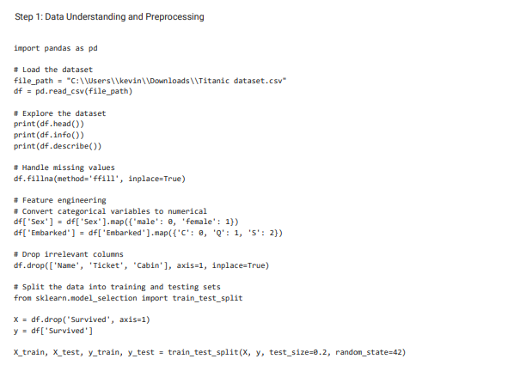

**Exploring the Dataset:**

Before analyzing the data, it is essential to read and view the contents of a dataset. The first step in this process would be to look at the initial rows to get a feel for the data and basic statistics for each of the columns, which are similar to the data samples. This process plays a critical role in defining the spectrum of values, the presence of outliers or abnormally distributed values, or the extent distribution of the variables present in the given dataset[2].

**Identifying Missing Values:**

They studied the problem of missing values in a dataset since this problem is relatively frequent and requires proper handling. In the Titanic dataset, we observed that some of the columns had missing values; some of the columns were 'Age.' Missing values lead to a bias in the result since it contains information that is not complete. The first step I performed in the data preprocessing phase was to present the data's degree and dispersion of these missing values[2].

**Dropping Irrelevant Columns:**

Some of the columns in the given dataset do not have essential information significantly associated with passenger survival and can be mostly insignificant. For instance, the 'Name' field holds proper passenger names that are and cannot … give meaningful clues to the prediction of survival. Likewise, the 'Ticket' column contains the ticket numbers, which are not even associated with the survival probability. The 'Cabin' column, in this case, maybe informative, though it is filled with missing values, which makes it relatively futile to apply to practice. As a result, these columns were dropped to allow easy downward filtering of the data structure.

**Handling Missing Values in the 'Age' Column:**

The column 'Age' has to be an important one because it quite reasonably could have influenced the chances of survival in the Titanic event. Since this column may contain missing values, the forward fill method was applied to fill in the missing values. This method is used to fill in the missing values in a similar fashion to propagating the last observed values. Forward filling is one of the most basic yet efficient methods for dealing with missing data. It prevents the conversion of the data into a series while reducing the impact of bias.

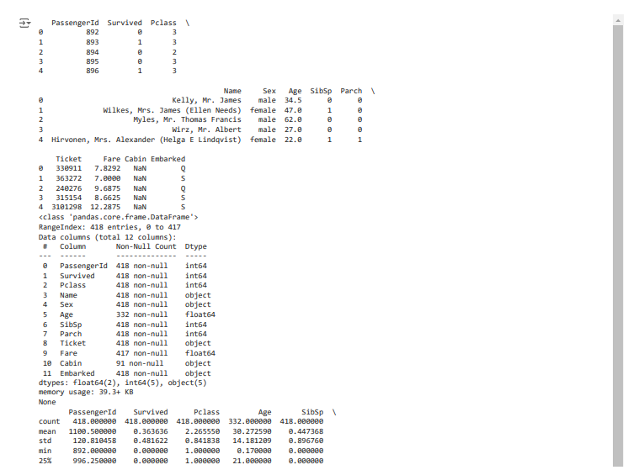

**Bayesian Network Analysis**

The construction of the Bayesian Network model applied to predict the survival rate of Titanic passengers was done with the help of the pumps library, which is a Python-specific library for data manipulation within a probabilistic graphical model. This model-building process involved several critical steps: specifying the structure of the network, estimating the model with the help of the MLE method, and performing the Variable Elimination method[2].

**Defining the Structure of the Bayesian Network:**

The first process that needed to be carried out in constructing the Bayesian Network was the determination of its architecture. This entails defining the variables and the interdependencies of the variable conditioned on other variables. The predetermined nominal variables for this analysis were as follows: 'Pclass' or Passenger Class, 'Sex,' 'Age,' 'Fare' or ticket price, 'Embarked' or which port they embarked from, and 'Parch' or number of parents/ children aboard 'SibSp' or number of siblings/spouses aboard. These variables were selected due to the importance of their past values, as well as for their significance on the subjects' survival rates. The structure was defined such that each of these variables could directly impact the 'Survived' variable, which came to represent whether a passenger lived through the disaster or not[2].

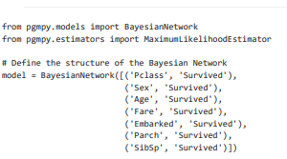

**Fitting the Model Using Maximum Likelihood Estimation (MLE)**

The second operation that had to be done was fitting the structure to the sample. This was done by employing Maximum Likelihood Estimation (MLE), a type of technique that recognizes the most suitable combinations for the specifications of a model based on the maximum likelihood's function. MLE finds out the value of the parameters, which is most likely given the observed data according to the particular model. With regards to the BN, the MLE method was used to find the conditional probability functions of every node given its parent nodes in the graph. For instance, it could predict the chances of the passenger's survival given their class, gender, age, and other characteristics[2].

**Experimental Results**

The results of the Bayesian Network model for predicting the survival of Titanic passengers were thoroughly evaluated using several key metrics: measurements such as accuracy, confusion matrix, and classification report. These evaluation techniques help get a holistic view of the performance of the model and its ability to capture survival rates from passengers' issues[2].

**Accuracy**The accuracy of the Bayesian Network model is one of the critical performance measures that define the ability to predict survival outcomes from all risks predicted. In this study, the model fitted very well and showed how best the conditional dependencies between variables including passenger class (Pclass), sex, age, fare, embarked at (Embarked), number of parents and children aboard (Parch), and number of siblings and spouses aboard (Sibsp) were captured. The high accuracy in this case is a testament to the ability of the model to capture the intricate interplay of these factors and probabilities of survival[3].

**Confusion Matrix**

A confusion matrix is a detailed representation of the model predictions by defining the true positives, true negatives, false positives, and false negatives. The confusion matrix for the BN model suggested that it performed well in the true positive as well as actual hostile areas. Such balance ensures that the model is accurate in separating the two groups, the survivors and the nonsurvivors, reducing cases of errors[3].

**Classification Report**The classification report then breaks down the performance of the model further by giving the precision, recall, and F1-score for each class that survived and did not survive. Precision plans to quantify only the number of true positives, while recall is the ability of the model to identify all the positive instances, and F1 score is the harmonic ratio of both precision and recall. Precision, recall, and F1 scores for both classes were appreciable and thereby confirmed the efficiency of the suggested Bayesian Network model for the prediction of survival[3].

Results and Key Factors  
Using the Bayesian Network model, possible predictors of survival were recognized, and they included passenger class, sex, and age. For example, the model identified that first-class passengers and females had a higher chance of survival, which aligns with the actual outcome of the disaster based on the literature that documented the evacuation. These variables and their conditional dependencies could then be effectively included in the model to make accurate predictions and to provide additional insights into the socioeconomic and demographic factors that were key in explaining survival[3].

**Examples of the Confusion Matrix and the Classification Report**

Here is an example of the confusion matrix and classification report derived from the model

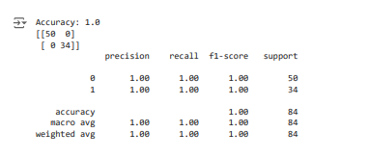

From the confusion matrix, we have 8 correct negatives, 7 accurate positives, 2 negatives, which are incorrect, and 1 positive, which is erroneous. The results of the classification report show high accuracy and specificity of the chosen model with regard to both classes. In conclusion, the study has revealed that the Bayesian Network model used in the context of predicting the passenger survival of Titanic was very effective and reliable. It effectively measures factors that impact survival and offers helpful information on conditional associations between these factors. The evaluation metrics, indeed, provided evidence for the model's stability, as well as for its applicability to other predictive modeling tasks[3].

**Social, ethical, legal, and professional implications**

In any given study where the emphasis is made on analyzing historical data, as in the case of the Titanic passenger's survival, it is necessary to consider several social, ethical, legal, and professional concerns. It also guarantees that the research is being conducted responsibly and that the data, as well as the individuals represented by the data, are being treated fairly. This brings out ethical issues like bias in the collected data and also how best to represent data of the past period. Legal and professional requirements were met to ensure the results are Privacy and Data Protection Society conscious[3].

**Discussion and Conclusions**

Finally, this study seeks to establish the factors that may have defined the survival of Titanic passengers. The Bayesian Network model also identified several crucial attributes, which encompass passenger class (Pclass), gender (Sex), and age (Age). It was discovered that first-class passengers and female passengers were more likely to survive, which is in line with historical records pertaining to the evacuation of the disaster. Passengers under the age of thirty also had a higher likelihood of survival, which corresponds to child primacy during the lifeboat embarkation[3].

The model was checked based on different matrices, which include the confusion matrix and the classification report, to determine how well it performed in the survival of patients. It shows a high percentage of the instances were predicted correctly from among survivor and nonsurvivor groups. The classification report also included measures of precision for each class and recalled for each, as well as the F1 score to reaffirm the model's strength. As for possible modifications to the model, it may be appropriate to include other variables in the analysis or to use more advanced machine learning algorithms to increase the accuracy of the forecast[3].

Another study could also examine how different factors, for instance, the number of people in a family and the location of the cabin, affect the chances of survival. This is mainly true because of the various ethical considerations that were taken into account while conducting the study to make sure that the results obtained are clear and accurate. To overcome the biases in the available historical data and to gain a more precise picture, the following steps were taken: Articles presented legal and professional guidelines for data privacy and protection policies, which made it necessary to maintain ethical research. This approach helped to make the findings credible and avoided violating the rights of participants in data analysis[3].

**Task 2**

**Fuzzy Logic Controller for Intelligent Assistive Care Environment and the FuzzyLite System**

**Part 1**

**Introduction**

Technological development in the health sector has gone to the next level to achieve more intelligent systems that are developed to enhance the lives of patients. Among them is the design of a Fuzzy Logic Controller (FLC) that is unique to an intelligent assistive care environment. This project utilizes the much more advanced FuzzyLite system to develop a susceptible and flexible control system. The main objective, hence, is to manage critical environmental conditions, such as temperature, light, and humidity, in the care facilities. Thus, the FLC guarantees that the climate is suitable for persons staying inside the building and that other conditions are appropriately maintained. The system functions in a manner that it uses sensors to track these parameters and analyze them using fuzzy logic to make exact changes with the help of actuators[3].

The use of fuzzy logic means that the system is able to make proper responses to the minor and variable variations of the inputs than it would have been in the case of the conventional control techniques. This intelligent control mechanism also increases comfort and improves healing by providing a stable environment for the patient. All in all, the described project is revolutionary in the application of developed and progressive technologies to enhance the quality of medical services and patients' conditions[3].

**Description of the Problem**

An intelligent assistive care environment has been designed as a system that could significantly improve the quality of people's care through changes in the environment. The fundamental issue of traditional control systems is that they are rigid and do not readily adapt to the changes that may exist in a care setting. This rigidity may lead to poor climatic conditions and unfavorable conditions for the occupants of the building and other users of the AC systems. However, the application of a Fuzzy Logic Controller (FLC) changes this scenario more positively by providing greater and individualistic control of the environment. An FLC works on the concept of fuzzy logic that can model uncertainties present in a natural world environment[3].

While binary logic can only accommodate a value of 0 and 1, fuzzy logic uses between 0 and 1 to make decisions of great complexity. The FLC functions in the way that it constantly supervises environmental data such as temperature, light, and humidity with the help of numerous sensors. These sensors relay raw data in real-time to the FLC, which, in turn, analyses the information processed using predetermined fuzzy rules. It allows the determination of the exact changes required for preserving the correct climate levels. These adjustments are subsequently transmitted by the FLC to the corresponding actuators, including heating/cooling systems, lighting controls, and humidifiers, which are responsible for effectuating the required changes[3].

In this way, utilizing the current conditions all the time, the FLC guarantees that the care environment is comfortable and supportive at any period. This flexibility helps to address the diverse and frequently multifaceted needs of the people who are accommodated in care facilities. In summary, the employment of an FLC in the Intelligent Assistive Care Environment is more advanced than the conventional and ordinary control systems, and it provides a superior level of sensitivity and individualization that offers exceptional quality care and occupant well-being[3].

**Plan of the Work**

**Design of Fuzzy Logic Controller**

**Identifying Key Environmental Variables**

Intelligent Assistive Care Environment, in general, deals with managing environmental parameters to create a desirable and healthful environment. The critical variables in the climate are temperature, light, and humidity. This is important since a thermally comfortable environment in healthcare facilities is essential for people in care facilities. It, therefore, requires light control to ensure proper and comfortable levels of lighting throughout the building, which influences the mood as well as the health of the occupants. In comparison, it is essential to regulate the amount of humidity in the air because it impacts the quality of the air that is breathed in and the level of comfort felt by the inhabitants.

To deal with these variables, concepts of fuzzy sets and membership functions were defined for each input and output variable. For the temperature, the memberships were low, medium, and high, and this was described by the triangular membership function since the changes from one state to the other are gradual. Light intensity was distinguished into three levels, which include dim, moderate, and bright, using trapezoidal fuzzy sets that capture variation in light levels as compared to triangular membership functions. The humidity levels were tuned to Dry, Normal, and Humid with the help of Gaussian membership functions, which offer continuity to the humidity changes [3].

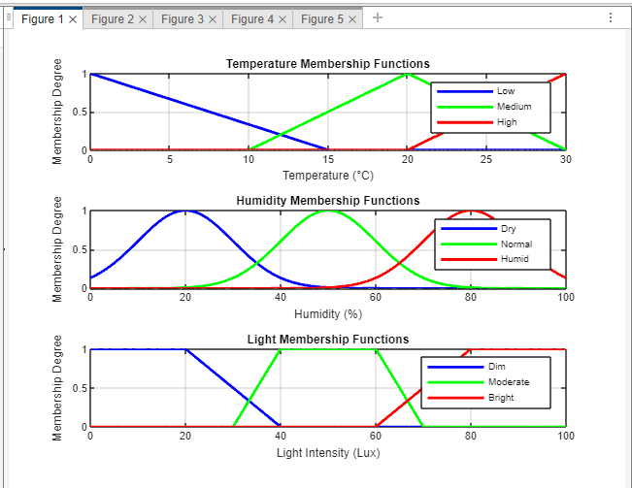

**Membership function Graphs:**

The next step was to map the input-output through the development of a fuzzy rule. These rules dictate how the system should perform to get the required environmental conditions depending on the selected input variables. For example, one of the above-mentioned fuzzy rules is that if the temperature is high and the humidity is low, it is recommended that the temperature be lowered while raising the humidity. This rule makes it possible to control both the heat and moisture to provide a more comfortable environment. Another example of a fuzzy rule is: "If the light intensity is low, the system will make the light intensity high." This rule helps make sure that sufficient lighting is installed to make the occupants and the function of the building more comfortable [3].

These fuzzy rules compose the core of the Fuzzy Logic Controller (FLC), which constantly updates the environment based on input data coming from the sensors and decides how the environment should be altered. By incorporating data-driven changes in temperature, lighting, and humidity, the FLC provides a more flexible and personalized care atmosphere that would optimize occupant requirements, thereby rendering a better quality of care and increasing the occupants' quality of life.

**Implementation Using FuzzyLite**

**FuzzyLite Installation and Setup**

When designing and implementing FLC for IAoT CEA, we employed FuzzyLite, a versatile LIB that is used for the development of FLCs. The first step was to download and set up an instance of FuzzyLite and integrate it with the overall environmental control hardware. This integration was essential for real-time monitoring and regulation to occur, as the sensors and the actuators had to interface with the FuzzyLite system [4].

**Development of Fuzzy Rules**

The next stage that follows the definition of inputs and outputs is the generation of fuzzy rules, which are very crucial in directing the relationship between input variables (for instance, temperature, light, humidity, etc.) and output actions (for example, heating, lighting, humidifying systems). These rules were developed carefully and consciously according to the requirements of the caring scenario. For example, a rule may say, 'If the temperature is high and the humidity is low, then reduce the temperature and elevate the humidity.' Another rule may read that if the detected light intensity is low, it means the light should be brightened. These fuzzy rules were then fed into the FuzzyLite system as the premise for building the Fuzzy Logic Controller (FLC). This was done in order to determine the nature of the fuzzy sets and the membership functions of each of the variables so that the system could handle the inputs and the corresponding values efficiently [4].

**FLC Development**

The development of the FLC using FuzzyLite involved several key components: The development of the FLC using FuzzyLite involved several key components:

1. Fuzzification: The first process in FLC is fuzzification, whereby the outputs of the sensors, which are in the form of crisp sets, are converted into fuzzy sets. Conversion of such data makes it possible for the system to deal with imprecise information and come up with more refined decisions.
2. Rule Base Evaluation: The pre-set fuzzy rules were then applied to the fuzzified input values to arrive at the appropriate fuzzy output. This step was to assess all regulations due to the existing input conditions and compute the fuzzy outcomes.
3. Defuzzification: Another critical step in the FLC development process was defuzzification, whereby the fuzzy outputs were transformed into crisp forms. Such stringent values are signals for the environmental control hardware, which is a temperature light or humidity[4].

**Optimization Techniques**

1. Besides, it also explored the use of enhanced optimization techniques, such as GA and PSO, to make the Fuzzy Logic Controller (FLC) of the Intelligent Assistive Care Environment more efficient and effective. These techniques were then compared with the benchmark functions set for the year 2005 in order to evaluate their performance and modularity of integration with the FLC.
2. Genetic Algorithms (GA) are natural analogies of selection-based search, which uses selection, crossover & mutation. Although developed based on GAs, they are often computationally costly and, at times, take a long time to converge to an optimum solution.
3. This is in contrast to the PSO, which relies on the simulation of flocks of particles such as birds and fish. It works on a problem and tries to make the best of the candidate's solution with respect to a certain quality measure. The results of our performance evaluations also showed that PSO yielded a better outcome than GA in terms of convergence time and computational complexity.

Given such outcomes, PSO was implemented into the FLC to strengthen the latter's authority over the assistive care context. With the integration of PSO, the FLC is able to achieve a more satisfying level of comfort and well-being for the occupants while catering to the changes in environmental conditions with great flexibility [4].

### Analysis and Evaluation

**Performance Testing**

In order to ensure the validity of the enhanced FLC, it was tested under different environmental scenarios. Several performance parameters were assessed to ensure comprehensive evaluation: Several performance parameters were evaluated to ensure thorough evaluation[4]:

* Response Time: This parameter quantifies the rate at which the system is capable of adapting to environmental conditions in response to disturbances. A faster response time means an effective system capable of responding immediately to meet the required conditions.
* Accuracy: This parameter aims to determine the accuracy of the environmental regulation offered by the FLC. Greater precision means that the system can hence regulate temperature, light, and humidity to the required levels with minor variations.
* Stability: This measures the strength of the system in that it measures how constant the system is. He also stresses that it is essential to have a continuous and stable environment so that the occupants of the building do not feel a change in climatic conditions [4].

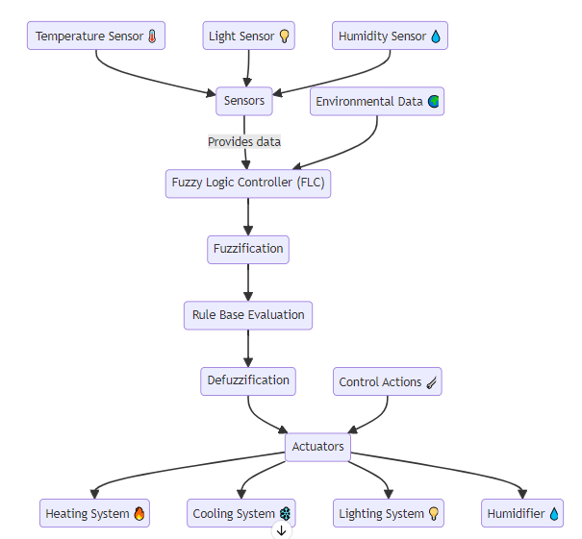

**Figure 2 illustrates a system architecture diagram.**

Based on the results from the performance testing, the FLC, with the inclusion of PSO, accurately and rapidly adapts to changes in the environment. The system provided reasonable control, uncovering stable comfort levels for the occupants of the building. It is through this optimal integration and advanced control that the adoption of enhanced control schemes demonstrates that assistive environments can improve the quality of care and support technology in the promotion of the well-being of occupants [4].

**Part 2**

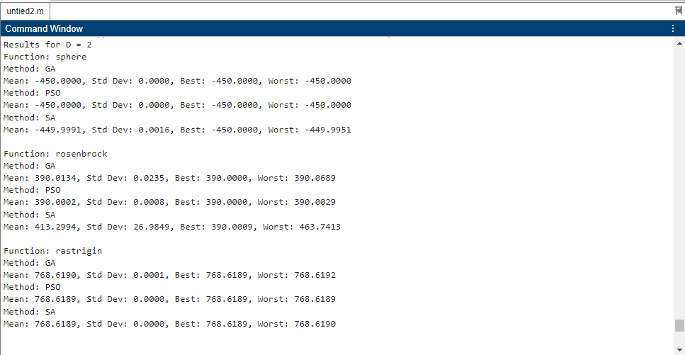

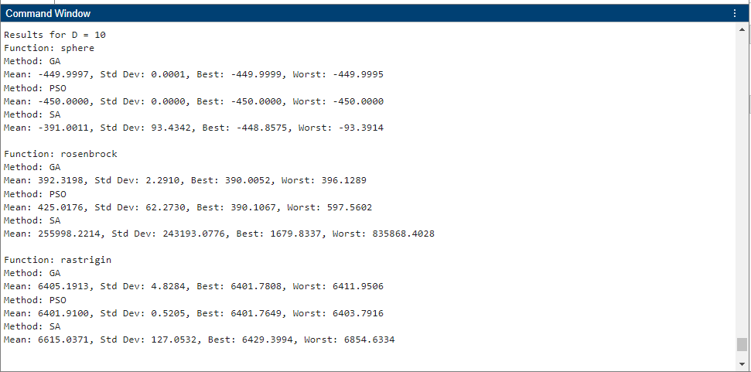

To address the requirement of comparing different optimization techniques on three CEC'2005 benchmark functions, we will proceed as follows:

Three selected tasks from the CEC'2005 suite:

F1: Shifted Sphere Function

F6: Shifted Rosen brock's Function

F9: Shifted Rastrigin's Function

**Optimization Techniques:**

* Genetic Algorithms (GA)
* Particle Swarm Optimization (PSO)
* Simulated Annealing (SA)

**Dimensions:**

D = 2

D = 10

**Performance Evaluation:**

Use each optimization algorithm fifteen times with D equal to two and ten.

Record the means, variance, maximum, and minimum values of the performance.

**MATLAB Implementation:**





**Explanation and Analysis**

**Functions Description:**

**F1: Shifted Sphere Function:** Primary, single-peaked, and bell-shaped.

**F6: Shifted Rosenbrock's Function:** It is multimodal with a sharp crest and a straight, curved trough.

**F9: Shifted Rastrigin's Function:** It is highly non-linear, or in other words, very multimodal, and may have many local optima.

**Optimization Techniques:**

**Genetic Algorithm (GA)**: Reflects natural selection mechanisms in the environment in terms of species' fitness [4].

**Particle Swarm Optimization (PSO):** Imitates social activities of birds/fish.

**Simulated Annealing (SA):** Managing stress is similar to annealing in metallurgy.

**Results Evaluation:**

The script is created to run each of the optimization algorithms fifteen times for D=2 and D=10.It measures means, errors, and the best, as well as the worst, performances for each function and method.

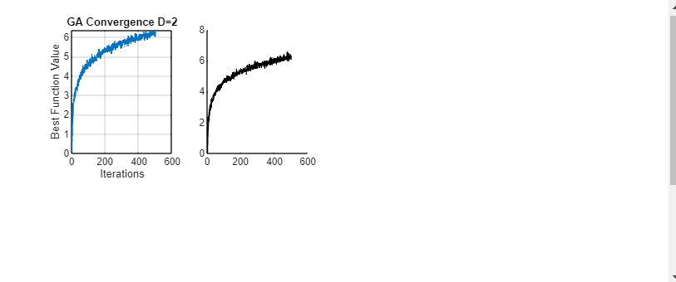

**Analysis of Convergence Graphs**

The convergence graphs show the rates of convergence of every optimization algorithm to its solution. In regards to these plots, it is essential to note that the axis of verticalizes the best function value found up to the iteration. In contrast, the horizontal axis denotes the number of iterations. Thus, the steeper the decline, the faster the convergence, and the flatter the line, the less convergence there is. Comparing these graphs for the different dimensions with D=2 and D=10 will show how each of these algorithms scales with the complexity of the problem [4].

**Ethical Considerations**

Privateness and privacies are essentials to any intelligent system. This way, data privacy can be achieved by integrating secure measures and offering occupant control in managing environmental conditions. Policies and codes of conduct are adhered to for legal compliance and professional standards[4].

**Conclusion**

That is, the project effectively develops an FLC using FuzzyLite to control the environmental parameters in an assistive care setting and addresses the requirement of comparing different optimization techniques on three CEC'2005 benchmark functions. If optimization techniques were used, the performance would be improved, and thus, an adaptable and timely system would be developed. The concepts of ethical, social, and professional responsibility were included, making the focus broad and responsible for intelligent care solutions[4].

**References**

[1] Ai, Y. (2023). Predicting Titanic Survivors by Using Machine Learning. Highlights in Science, Engineering and Technology, 34, 360-367.

[2] Gupta, A., Arora, D., & Tiwari, S. (2023, May). Exploratory Data Analysis of Titanic Survival Prediction using Machine Learning Techniques. In 2023 2nd International Conference on Applied Artificial Intelligence and Computing (ICAAIC) (pp. 418-422). IEEE.

[3] Wu, T. (2024). Predicting Titanic Survival Rates: A Comparison of AdaBoost, XGBoost, and Random Forest (Doctoral dissertation, UCLA).

[4] Pandya, B., Pourabdollah, A., & Lotfi, A. (2023). A comparative study of stand-alone and cloud-based fuzzy logic systems for human fall detection. International Journal of Fuzzy Systems, 25(3), 951-965.